THERMAL ENERGY and HEAT – Study notes
Complete the following sentences and tasks to make a set of study notes on Thermal energy and Heat
DEFINITIONS:  Click to write energy (NOT heat energy) is the energy possessed by an object because of movement of it's particles. Click to write is a way of measuring the level of thermal energy is an object.  Click to write is the movement (transfer) of thermal energy from warmer objects to cooler objects.  Click to write is the transfer of the heat through a solid object.  Substances that conduct heat readily are called Click to write , while substances that don't conduct heat readily are called Click to write .  Click to write is the transfer of heat energy caused by the movement of a fluid.  Click to write is the transfer of energy by infrared waves. |  |  | THIS MEANS THAT:  The hotter the object is (the higher it's temperature), the Click enter text the particles in it are moving.  Heat can be transferred in three distinct ways - Click to write , Click to write , and Click to write.  Convection Click to write due to warmer air Click to write and cooler air Click to write is a common mechanism by which thermal energy is transferred in the air. Click to write breezes are created by this.  Click to write objects (we can't see through) absorb radiant heat which hits them. Click to write coloured objects absorb more radiant energy and get Click to write than reflective or Click to write colours. |  |  | Fill in the venn diagram  Click to write  Click to write  RADIATION  CONVECTION  CONDUCTION  Click to write  Click to write
WORDS TO USE  Thermal  insulators  Temperature Conduction Opaque  light Conduction hotter | Heat radiation rising Faster convection conductors  Convection Sea falling currents Radiation Dark | 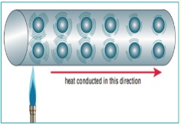  Conduction – Click to describe what is happening in the diagram |  | 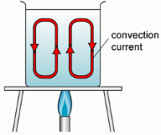  Convection - Click to describe what is happening in the diagram | 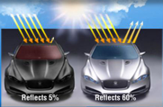  Radiation - Click to describe what is happening in the diagram

